**GARAGE MANAGEMENT SYSTEM**

**College Name: Kumaraguru College of Liberal Arts and Science**

**College Code:** bruax

**TEAM ID:**  **NM2025TMID25583**

**TEAM MEMBERS:**  **4**

**Team Leader Name:**  KANITHRA.S

**Email:** skanithra6@gmail.com

**Team Member 1:** NAKSHATHRA.D.V

**Email:**  nakshathradv@gmail.com

**Team Member 2:** DIVYA DARSHINI

**Email:**  divyadharshini.23bds@kclas.ac.in

**Team Member 3:** DHARSHINISRII

**Email:**  dharshinisrii2005@gmail.com

**Introduction**

The **Garage Management System** built on Salesforce helps garages run more smoothly by simplifying everyday operations. It keeps track of vehicle servicing and repairs, manages spare parts, and stores customer information in one place. Mechanics’ performance can be monitored, while invoices are generated automatically to save time and reduce errors. With easy-to-read reports and dashboards, garage owners get a clear view of their business, allowing them to make smarter decisions, improve efficiency, and provide a better experience for their customers.

**Purpose of the Garage Management System**

The Garage Management System in Salesforce is designed to make garage operations easier and more efficient by automating key tasks such as service tracking, spare parts management, billing, and customer records. The system provides accurate reports and interactive dashboards for better business monitoring, supports mechanics in working more productively, and ensures customers receive well-organized and timely service. Ultimately, it helps garages save time, reduce errors, and deliver a smoother customer experience.

**What You Will Learn**

• **Set up your Salesforce Developer Org** and get hands-on with the platform.

• **Design custom objects and fields** to manage key records like Customers, Appointments, Services, and Billing.

• **Connect your data** by building relationships between objects.

• **Implement security controls** using profiles, roles, and sharing rules.

• **Automate routine tasks** with Flows and Apex triggers to save time and reduce manual work.

• **Build insightful reports and dashboards** to track performance and make data-driven decisions.

• **Apply Salesforce CRM concepts** to a real-world garage management scenario.

**Creating Developer Account:**

By using this URL[**-**](https://www.salesforce.com/form/developer-signup/?d=pb) https://orgfarm-f331f6164a-dev-ed.develop.lightning.force.com/lightning

**Created objects: Customer Details, Appointment, Service records, Billing details and feedback**

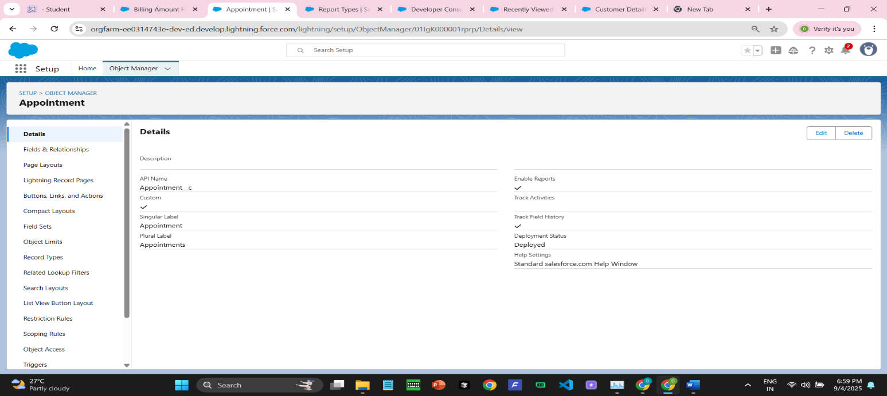

**Creating Custom Tab:**

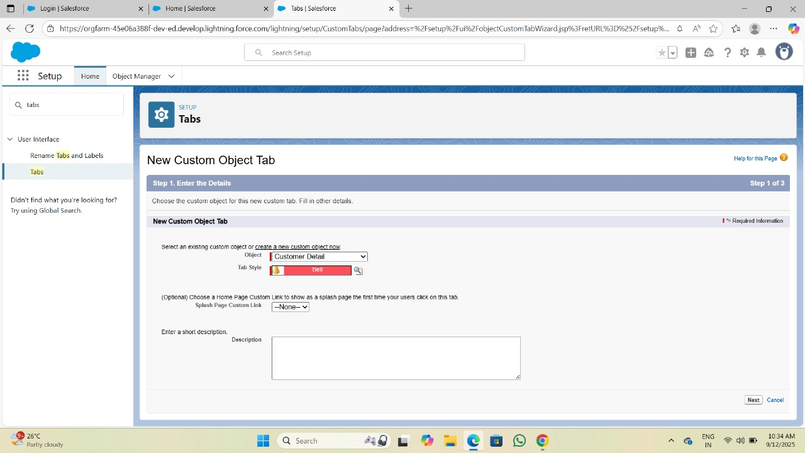

**DUPLICATE RULES**

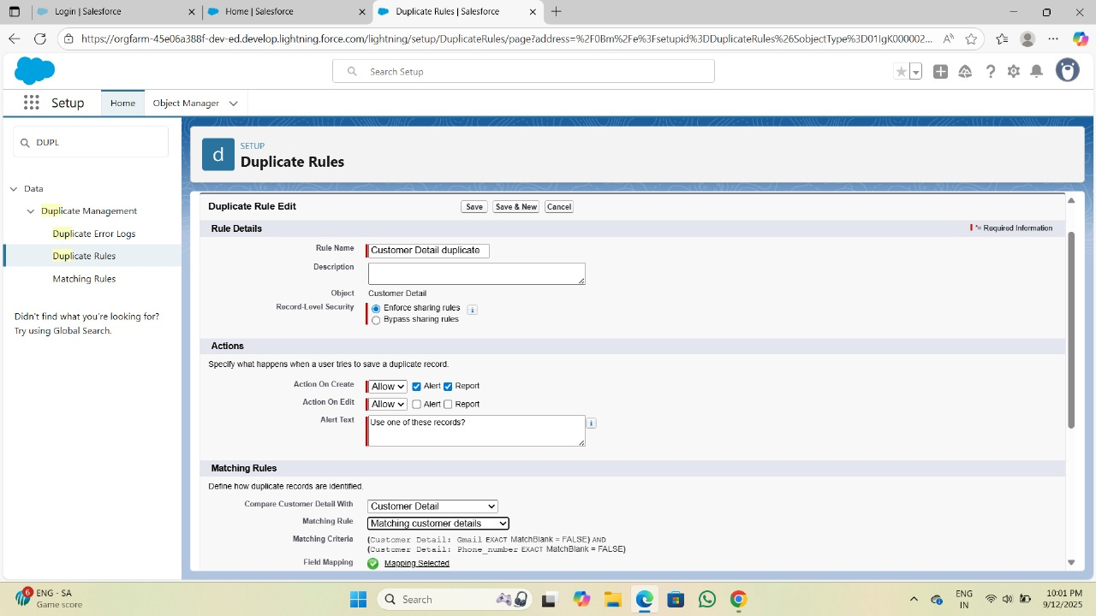

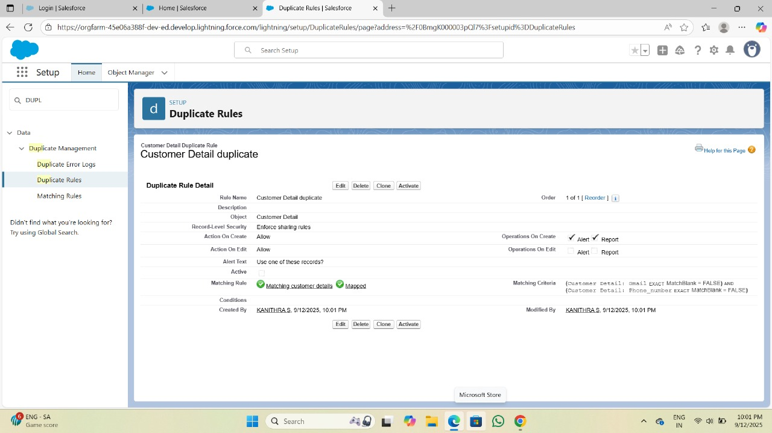

**PROFILE:**

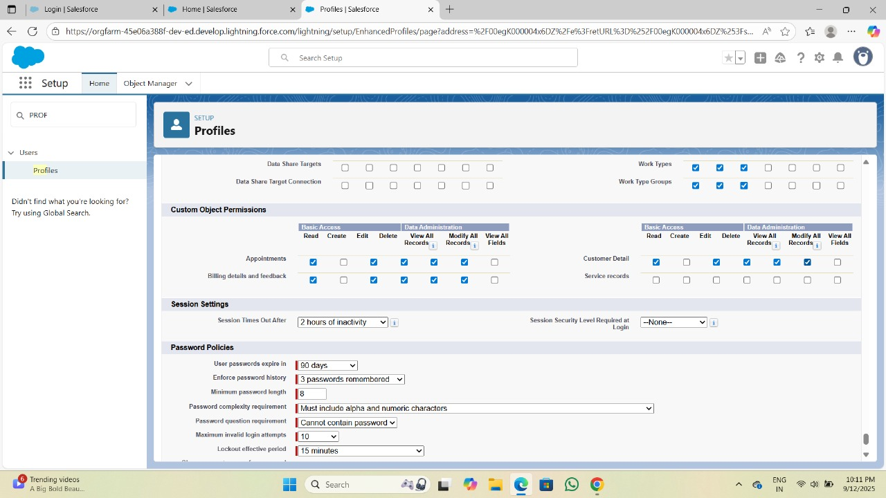

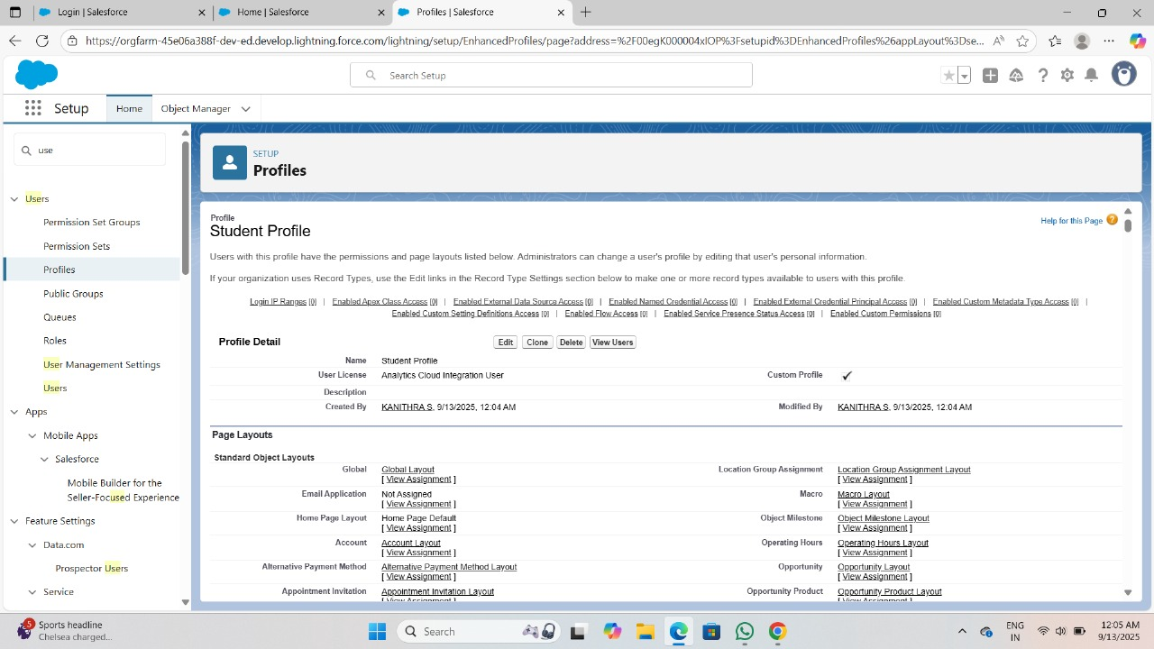

**ROLES:**

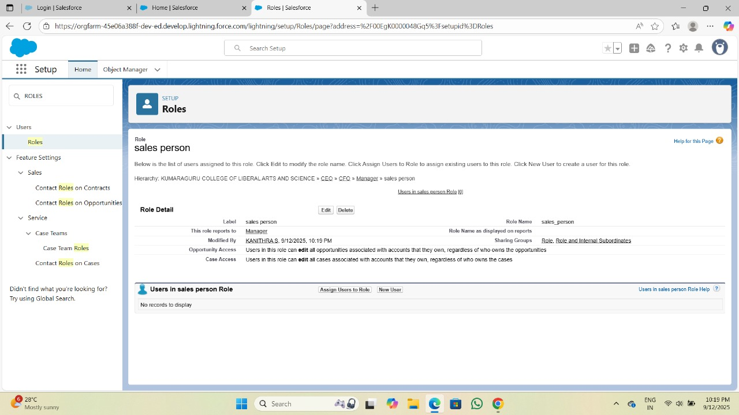

**USERS:**

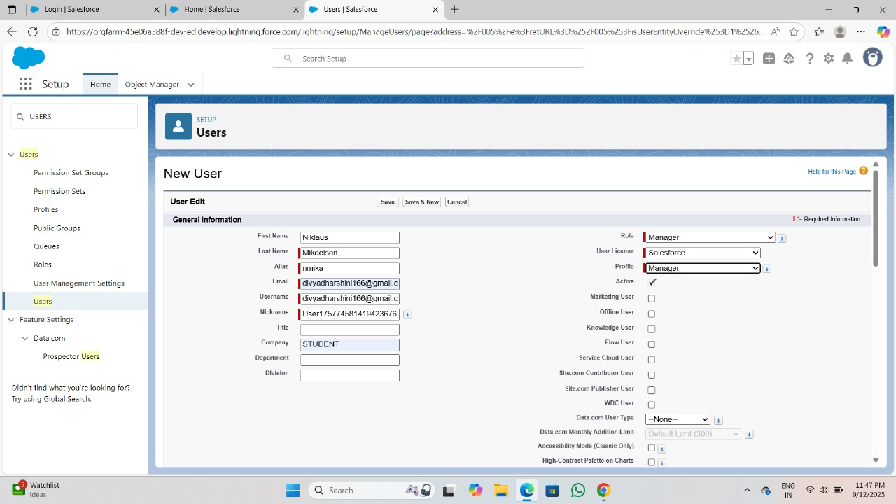

**PUBLIC GROUP:**

**Sharing Setting:**

Implemented Flows for monthly rent and payment success

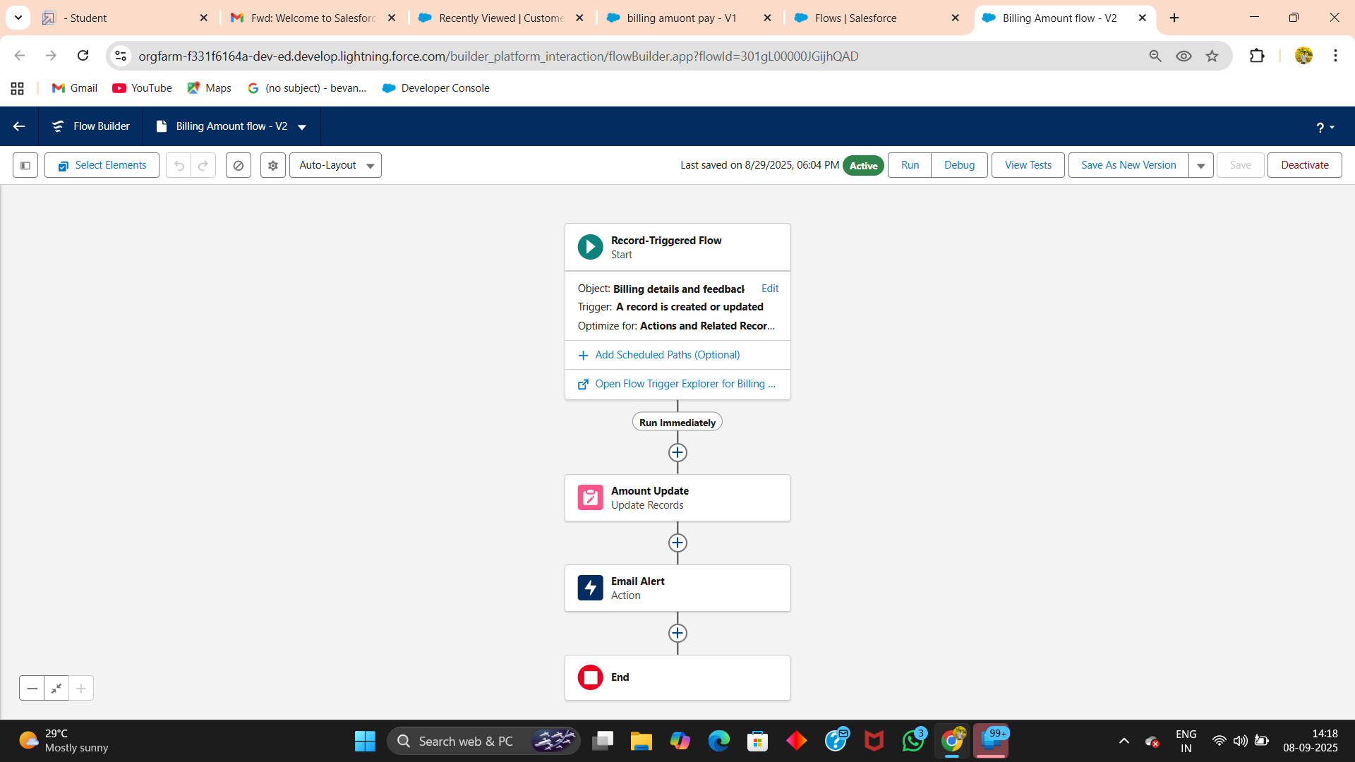

**Apex:**

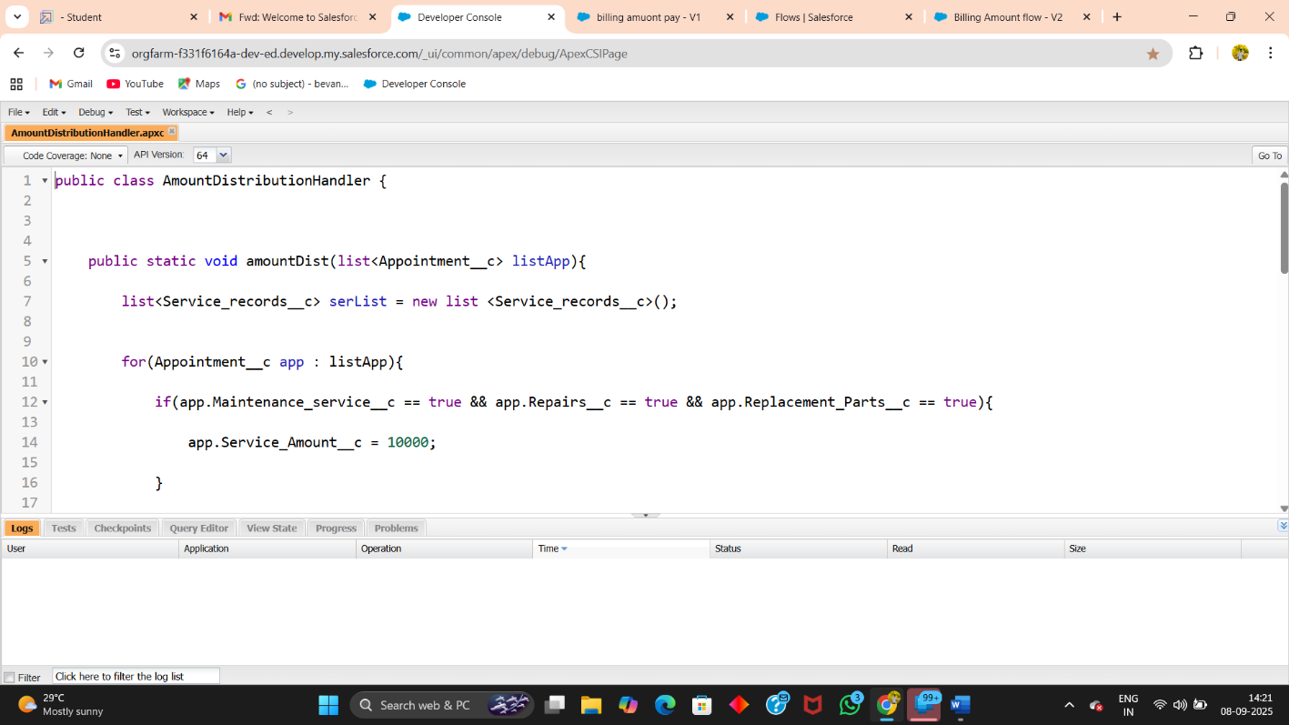

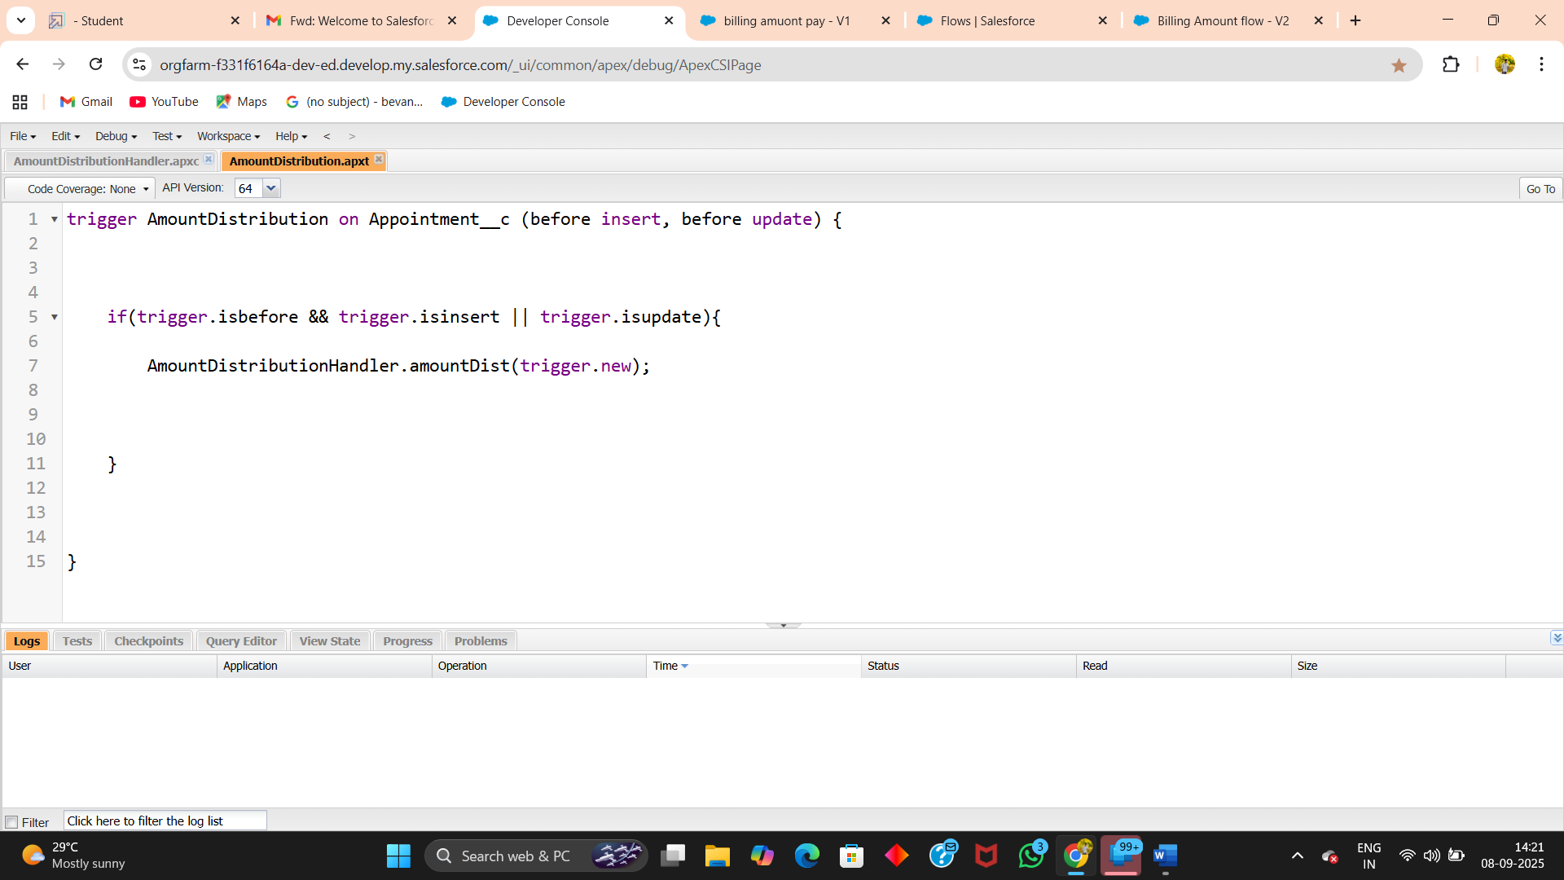

**Reports:**

**Create Dashboard Folder**

**Create Dashboard**

**FINAL OUTPUT**

**ADVANTAGES & DISADVANTAGES**

**ADVANTAGES:**

* **Streamlined operations** – Automates key tasks such as billing, service tracking, and inventory management.
* **Smarter decisions** – Offers real-time reports and dashboards for quick and informed decision-making.
* **Higher efficiency** – Boosts mechanic productivity and helps deliver better customer experiences.
* **Fewer mistakes** – Minimizes errors that often come with manual record keeping.
* **Flexible and scalable** – Easily customized and expanded within Salesforce to fit growing business needs.

**DISADVANTAGES:**

* **Technical expertise required** – Proper Salesforce setup and customization demand skilled resources.
* **Internet dependency** – The system cannot function offline, requiring stable connectivity.
* **Cost considerations** – Initial setup, licensing, and customization may involve significant expenses.
* **Training needs** – Staff must be trained to use the system effectively and take full advantage of its features

### **CONCLUSION**

The Garage Management System in Salesforce offers a reliable and efficient way to handle everyday garage operations. By bringing together service tracking, inventory control, billing, and reporting in a single platform, it helps reduce manual work and ensures smoother workflows. While the system does require proper setup, investment, and staff training, the long-term benefits—such as higher productivity, improved accuracy, and greater customer satisfaction—make it a smart and future-ready solution for modern garage businesses.

## APPENDIX

trigger [TriggerName] on [ObjectName] (before|after events) {

// Trigger logic goes here

}

trigger AmountDistribution on Appointment__c (before insert, before update)

if ((Trigger.isBefore && Trigger.isInsert) || Trigger.isUpdate) {

AmountDistributionHandler.amountDist(Trigger.new);

}

}